MA374-LAB10
Nikhil Agarwal
Roll:11012323
- GBM in real world:

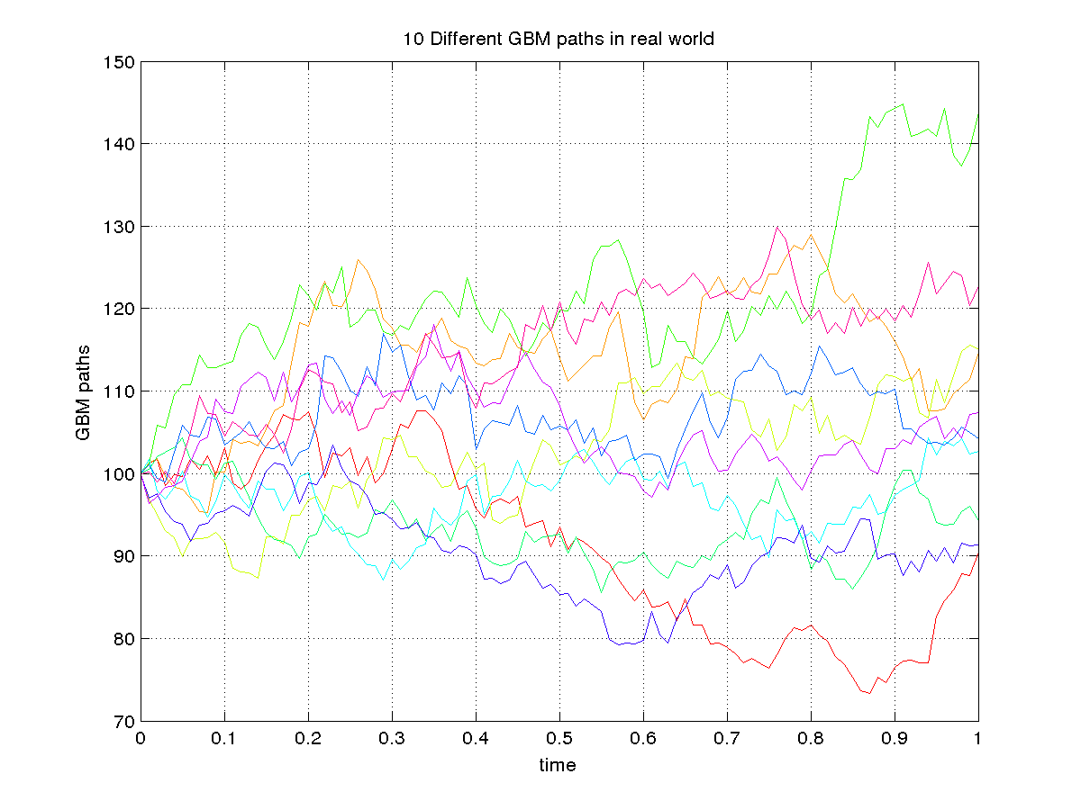
GBM in risk-neutral world:
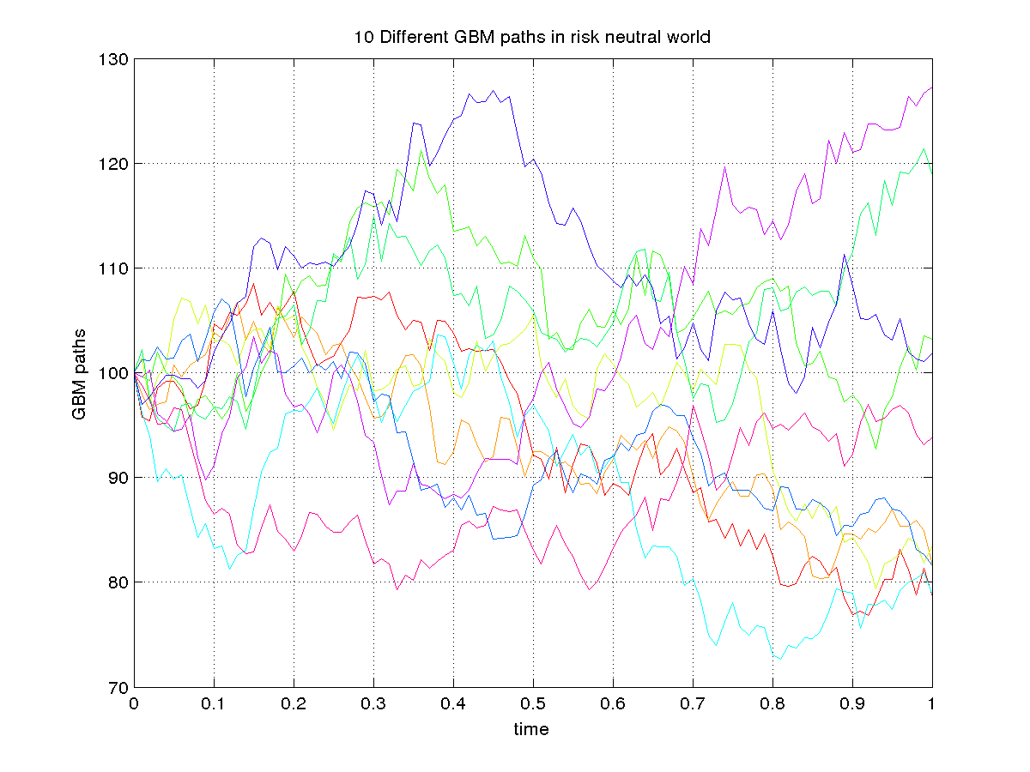
2.

With 95% confidence interval

for k = 105 :
for Asian call option confidence intervals are: [1.745049 , 1.789619]
for Asian put option confidence intervals are: [5.391835 , 5.478276]
for k = 110 :
for Asian call option confidence intervals are: [0.671610 , 0.702342]
for Asian put option confidence intervals are: [9.196468 , 9.280195]
for k = 90 :
for Asian call option confidence intervals are: [11.177372 , 11.264307]
for Asian put option confidence intervals are: [0.228759 , 0.241862]

From looking at the above intervals we can say that we are 95% sure that the value of call and put lie in the given ranges for k=105,110 and 90 respectively.

3.

